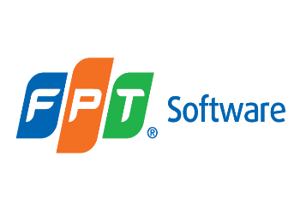

***Entity Framework***

**Lab Guides**

|  |  |
| --- | --- |
| Document Code | 25e-BM/HR/HDCV/FSOFT |
| Version | 1.1 |
| Effective Date | 20/11/2012 |

**Hanoi, 07/2019**

RECORD OF CHANGES

|  |  |  |  |  |  |
| --- | --- | --- | --- | --- | --- |
| No | Effective Date | Change Description | Reason | Reviewer | Approver |
|  | 01/Oct/2018 | TuTB create new | Draft |  |  |
|  |  |  |  |  |  |
|  |  |  |  |  |  |
|  |  |  |  |  |  |
|  |  |  |  |  |  |
|  |  |  |  |  |  |
|  |  |  |  |  |  |
|  |  |  |  |  |  |
|  |  |  |  |  |  |
|  |  |  |  |  |  |

Contents

Lab: EF Code-First 4

Objectives: 4

Prerequisites: 4

Problem Description: 4

Guidelines: 4

Step 1: Open Visual Studio and create a console project 4

Step 2: Check .net Framework version 4

Step 3: Add **Student** model 5

Step 4: Add **Grade** model 5

Step 5: Create context 5

Step 6: Add a student using context class 6

|  |  |
| --- | --- |
|  | **CODE: NEFW.S.L003**  **TYPE: SHORT**  **LOC: 120**  **DURATION: 30 MINUTES** |

# Lab: EF Code-First

Objectives:

* Create a simple application for XYZ School. Users of this School application should be able to add and update students, grades, teachers, and courses information..

Prerequisites:

* Download and installs Visual Studio (included .net Framework).

Problem Description:

* Instead of designing database tables first, let's start creating classes for our school domain, as and when needed. First, create the Student and Grade classes where every Student is associated with one Grade as shown below. This is called a one-to-many relationship. Learn about how EF manages the relationship between entities (domain classes).

Guidelines:

### Step 1: Open Visual Studio and create a console project

### Step 2: Check .net Framework version

Go to Project in the menu -> {project name} Properties.. - and make sure that the project's target framework is .NET Framework 4.5, as shown below.

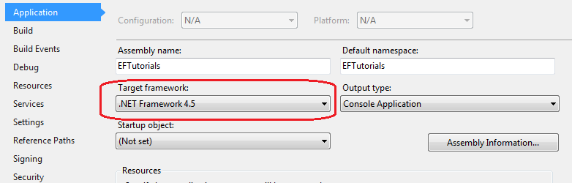

### Step 3: Add **Student** model

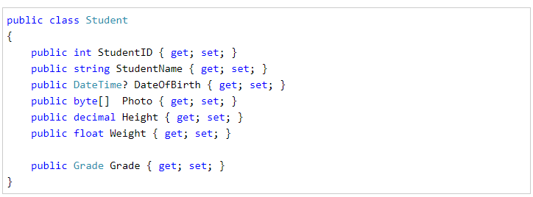

### Step 4: Add **Grade** model

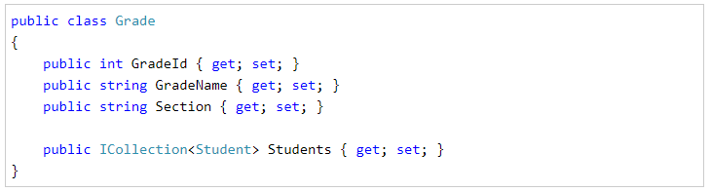

### Step 5: Create context

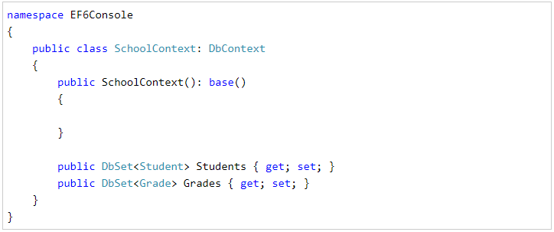

### Step 6: Add a student using context class

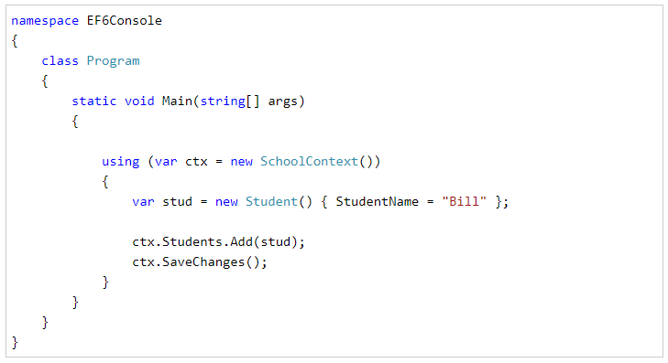

Step 7: Check result

